

Beyond the Smart Camera: Why "Out-of-the-Box" Vision Systems Struggle in Real Manufacturing
Almost every manufacturing leader has experienced an automation solution that looked simple in principle, but proved difficult in practice.
You buy a highly rated, out-of-the-box (OOTB) smart camera. The sales demo looks flawless. But once it reaches the factory floor, reality sets in. Ambient light shifts, parts vibrate, or a harmless cosmetic mark triggers a false reject that interrupts the line. Within weeks, the system is bypassed because it cannot reliably handle real operating conditions.
To understand why this happens, and what to do about it, it helps to use a familiar strategy tool, the Stacey Matrix.

Understanding the Stacey Matrix
Developed by management theorist Ralph Stacey, this framework helps organisations choose the right tool for the job by mapping two questions:
- The "What" (How well do we agree on the requirements?)
- The "How" (How certain are we about the technical solution?)
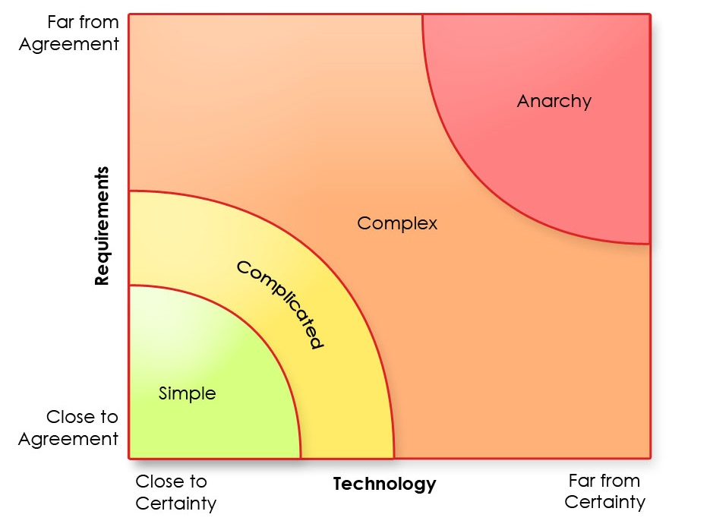
When conditions are predictable, you are in the Simple zone. As variables increase, you move into the Complicated or Complex zones. If control breaks down completely, you enter Anarchy.

Translating Stacey to the Vision Inspection World
To see why off-the-shelf vision systems often struggle, we can translate the Stacey Matrix into manufacturing terms:
- The Horizontal Axis becomes Physical Certainty (The "How"): How stable is the product and its environment?
  - This includes product-level challenges such as glare from packaging variation, motion blur on high-speed lines, and complex shapes that cast shadows over potential defects.
  - It also includes plant floor conditions such as changing ambient light, variable product presentation, machinery vibration, airborne debris, and washdown moisture that can affect image quality.
- The Vertical Axis becomes Defect Agreement (The "What"): How clearly defined is the flaw? Is it a binary check, such as part present or missing, or something more subjective, such as a harmless mark versus a critical defect?
  - This includes the natural and acceptable variability in your product, and how products present due to the realities of the manufacturing process.
  - It also includes how quality is assessed, from pass or fail decisions to grading outcomes. Many industries allow for acceptable natural variation in the finished product.
A successful automated vision inspection system depends on addressing both the physical realities of the factory environment and the inspection criteria that define product quality.

The Three Manufacturing Zones
1. The Simple Zone: Where OOTB Systems Can Work Well
In this quadrant, parts are consistently fixtured, lighting is controlled, and the defect is binary, such as verifying that a cap is fitted to a bottle. Traditional, rule-based smart cameras can perform well here. They count pixels, find edges, and apply simple inspection rules effectively.
The common mistake is assuming that every inspection task on the factory floor sits in this zone.
2. The Complicated Zone: The Physical Gap
Here, you know exactly what defect you are looking for, but physical certainty is low. Your line may run at high speeds, parts may rotate freely, or the material may be highly reflective.
Generic, all-in-one cameras often struggle here because standard lenses and basic lighting cannot overcome the physical constraints. Bridging this gap usually requires considered hardware engineering, such as high-resolution line-scan cameras, 3D industrial sensors, dynamic focusing lenses, or specialised lighting to reduce glare or highlight defects.
3. The Complex Zone: The Cognitive Gap
Here, the physical environment may be relatively stable, but the defect definition is highly variable. Think of organic materials, cast metals, or complex welds. Defining what makes a part unacceptable often requires human judgement.
Traditional vision software relies on rigid rules. If those rules are too tight, your false reject rate rises and creates an unnecessary bottleneck. If they are too loose, bad parts can pass through. Bridging this gap often requires more advanced software and AI. Deep learning models can be trained on acceptable variations, helping the system emulate expert human judgement at line speed.

Delivering True Value on the Factory Floor
An off-the-shelf vision system tends to treat every problem as if it belongs in the Simple Zone. When it meets the variability of a live production line, that assumption often breaks down.
Real value in manufacturing inspection is rarely found in a catalogue or a generic box. It comes from a considered approach that addresses the physical gap with fit-for-purpose hardware, and the cognitive gap with more capable software.
For more complex inspection tasks, the better path is to design a system around the realities of your production environment. Bringing the best mix of technology and a functional AI process in a single custom system is the answer to truly meet the required outcomes.

